**STEPS TO INSTALL EXAM BRANCH PORTAL**

1. **Download and install softwares:**

* [Node](https://nodejs.org/en/download)
* [MySQL](https://dev.mysql.com/downloads/file/?id=520407)
* [Git](https://git-scm.com/download/win) (Recommended for maintaining latest data)
* [VS Code](https://code.visualstudio.com/download) (optional)

Here are the installation steps:

1. **Node:**
   1. Open the link and download the file

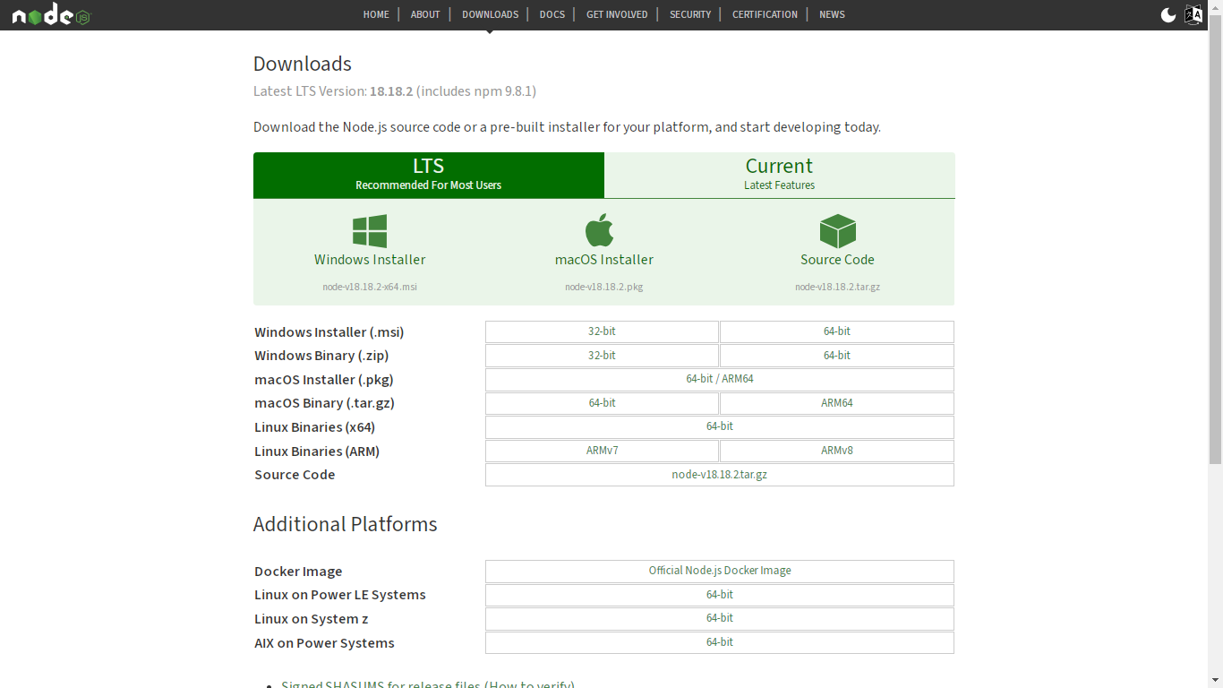

* 1. Keep clicking next until the installation starts. Once it is installed, you get a confirmation. You can then close the window.

1. **MySQL:**
   1. Open the downloaded file and follow these steps

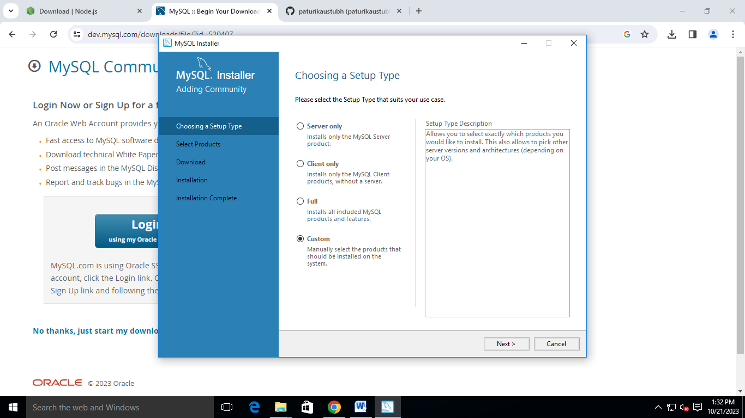

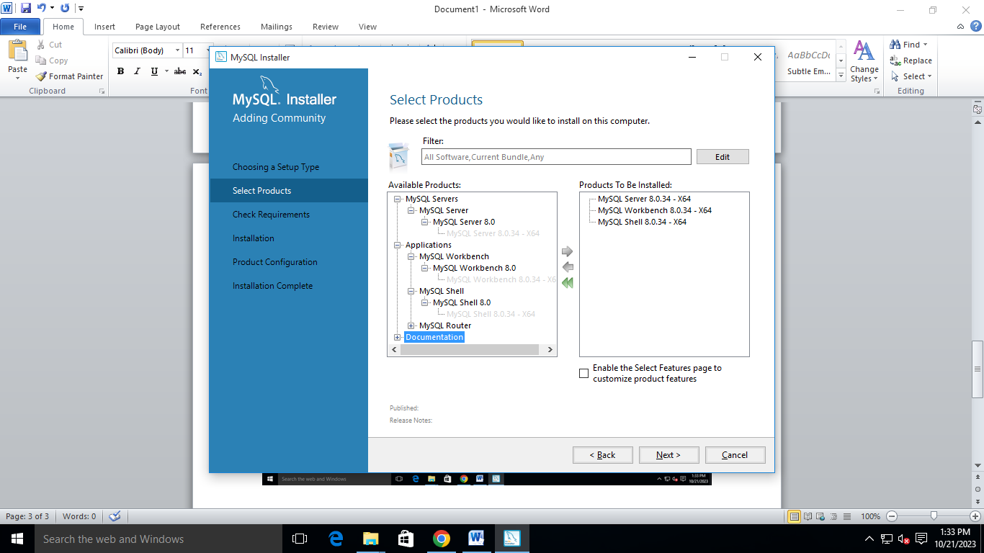

`

* 1. After selecting these products, click next, then “Execute”
  2. Form here keep going next until you land here:

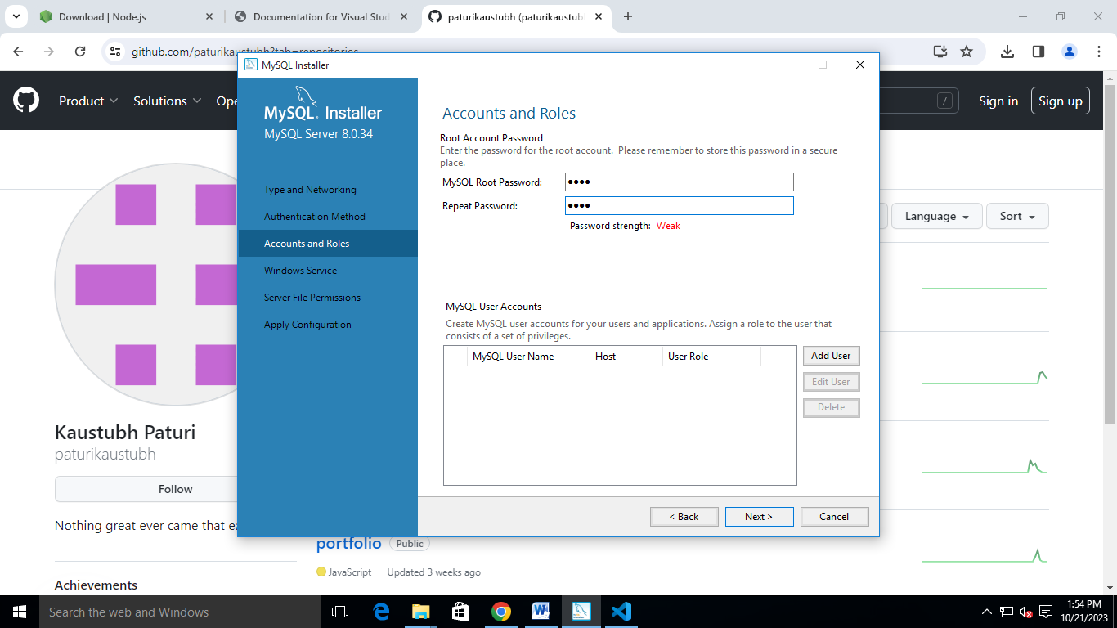

* Here, give the password as *‘root’.* Then keep going next.

1. **Git**
   1. After downloading git, keep going next until you land on this page

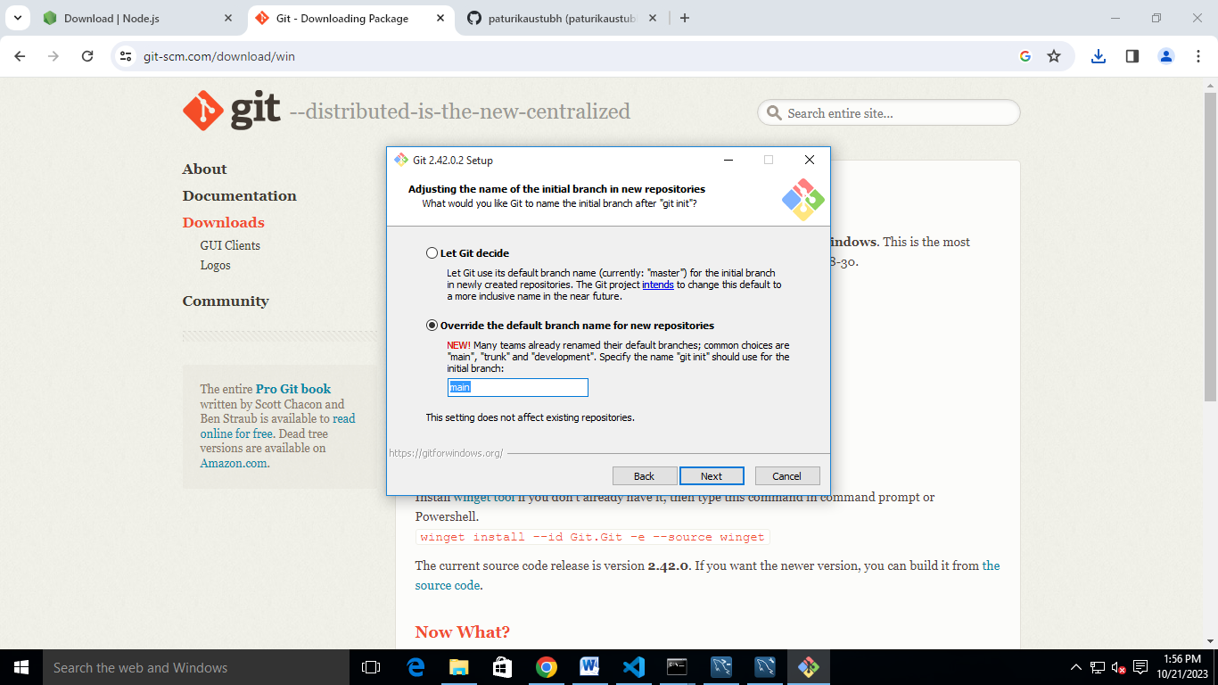

* 1. Select the highlighted option and keep going next.

1. **Managing files and folders**
   * In the file manager, create a new folder in your desired location and name it ‘*Exam Branch Portal’.*
   * Open the folder and open command prompt to that location. You can type *cmd* in the address bar.
   * Paste this command ‘*git clone* [*https://github.com/paturikaustubh/ExamBranch-Client.git*](https://github.com/paturikaustubh/ExamBranch-Client.git)*’.* This will create the client folder. You can rename this folder to ‘*Client’*
   * Now in the same command prompt, paste ‘*git clone https://github.com/paturikaustubh/ExamBranch-Server.git’ .* This will create server folder. You can rename it to ‘*Server’.*
   * Once the above processes are done, create a new file ‘*serverIP.txt’* in the client folder.
   * Along with server and client folder, create another folder name ‘Downloads’.

1. **Installing packages**
   * For both the folders (server and client), open command prompt separately and type ‘*npm i’.* This will install required files for both client and server.
2. **Creating database**
   * Open *‘MySQL Workbench’* and select

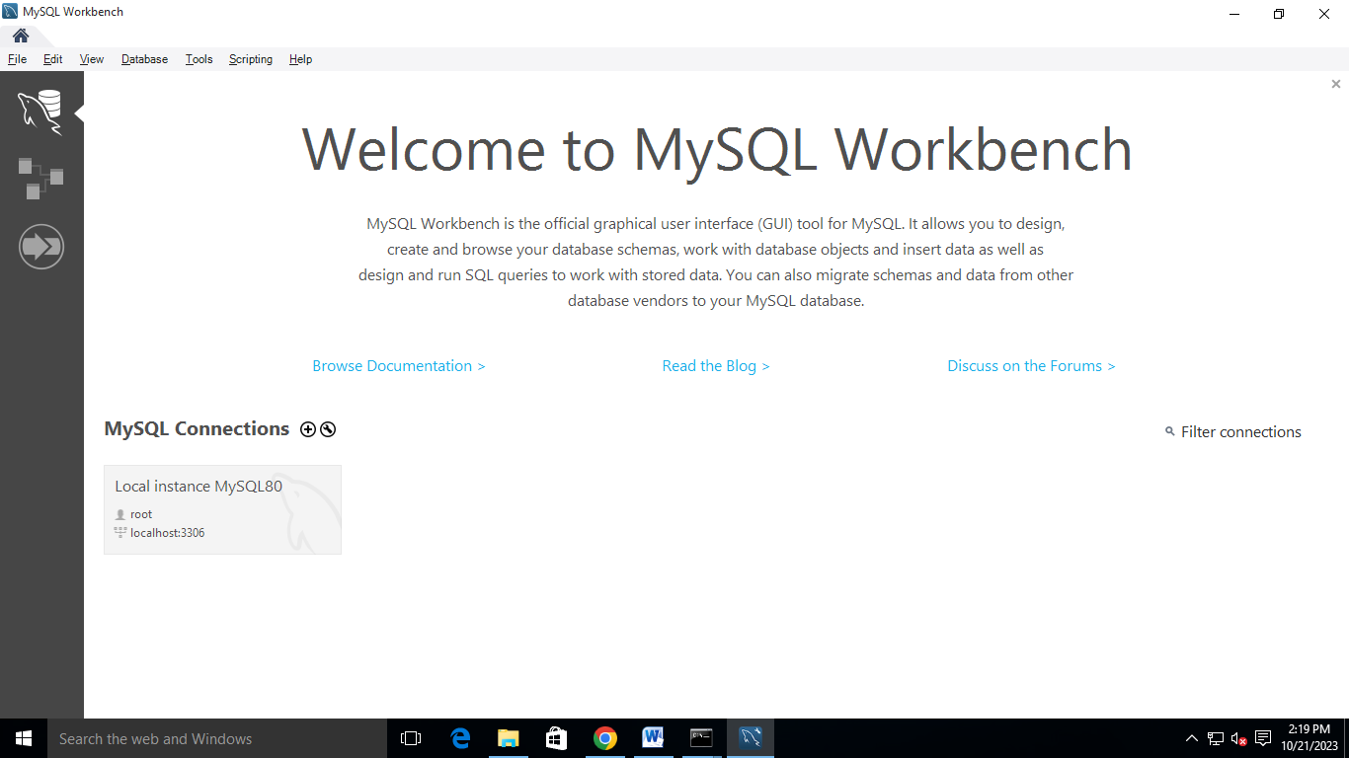

* For the password, enter ‘*root’.*
* This will open a blank page.
* Now got to File > Open SQL Script

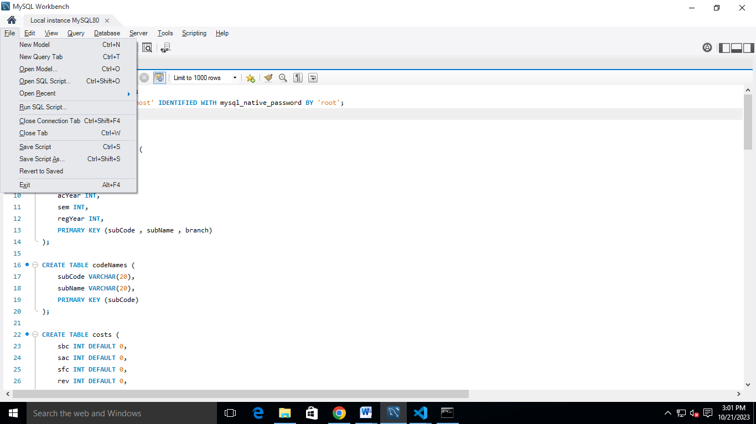

* Navigate to the server folder and open ‘*Create Database’* file.
* Now execute the file by clicking on ‘*Lightning’* icon button*.*

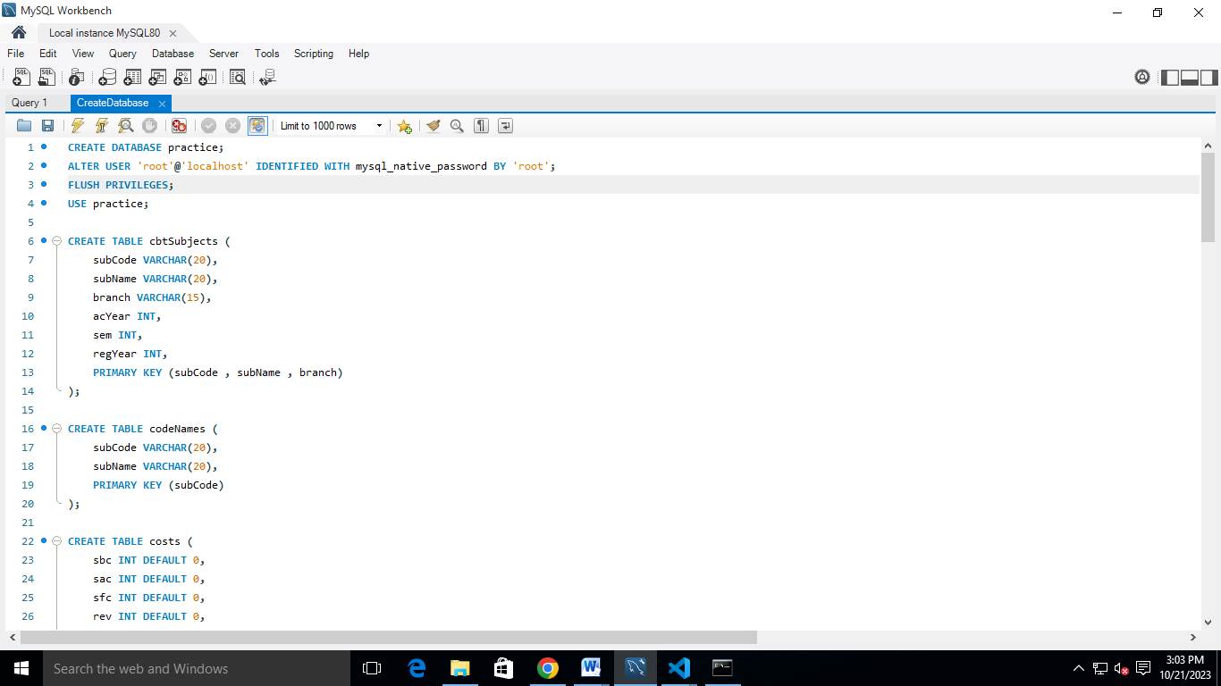

1. **Starting the application**
   * Once you are done with all the previous steps, open the start scripts from each folder respectively. For client it is ‘*startClient’* and for server it is *‘startServer’*. You can find them in their respective folders.